

Weekly Executive Summary

Period: 16 March 2001 to 23 March 2001

WEEKLY EXECUTIVE SUMMARY

INDEX: Page

Profit and Loss Analysis 3
Summary Comments 3
Risk Analysis 5
Curves and Positions 6
UK Power: Price Curves and Curve Shift 6
UK Power: Discounted volumes and changes in volumes 6

Continental Power: Price Curves and Curve Shift 10
Continental Power: Bilateral discounted volumes and changes in volumes 11
Continental Power: Pool discounted volumes and changes in volumes 13

Nordic Power: Price Curves and Curve Shift 15
Nordic Power: Discounted volumes and changes in volumes 16

UK Gas: Price Curves and Curve Shift 18
UK Gas: Discounted volumes and changes in volumes 19

Continental Gas: Price Curves and Curve Shift 21
Continental Gas: Discounted volumes and changes in volumes 22

Eastern: Positions 23
Eastern: Vega Positions 24

Metals: Price Curves and Curve shift 25
Metals: Discounted volumes and changes in volumes 26

Australian Power: Price Curves and Curve Shift 29
Australian Power: Changes In Forward Curves 29
Australian Power: Discounted volumes and changes in volumes 29

Credit Trading: Price Curves and Curves Shift 31

Profit and Loss Analysis

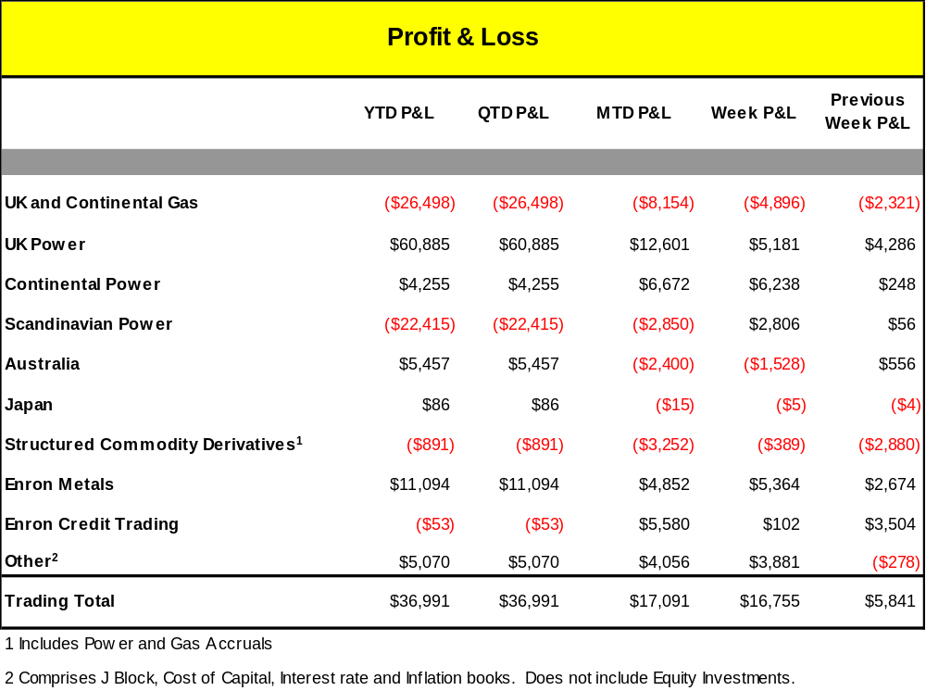

Summary Comments

Over the week the UK and Continental Gas Books reported total net trading P/L of $(4,896k). The total net position held by both books is now short (42.9) bcf, compared to a short (48.9) bcf position of the previous week. Of this total P/L, the UK Gas Book reported P&L of $(4,860k) and the forward delta position is now 10 bcf shorter at (34) bcf short. The P&L loss is mainly attributable to the book’s short delta position between September 2002 and January 2004 as prices increased slightly this week. Although this week saw volatile prompt markets, it is at the back end of the curve that the biggest moves occurred. On the prompt side, colder weather than expected and the news that the InterConnector will not switch flows was offset by disappointing demand figures for next week. As far as the curve is concerned, the upward movement witnessed this week is said to be due to the forthcoming implementation of NETA. The renegotiation of electricity contracts are, in effect, possible drivers as players might be hedging on fuel purchase.

The Continental Gas Book reported a P/L loss of $(30k) over the traded week 16th to 23rd March 2001 on a position which moved from (4bcf) short to (9bcf) short. The curve moved up at the front end on the back of NBP strength as unexpected cold weather and the lack of gas in storage affected prompt prices. Capping of interconnector flows meant that Continental Players could not take full advantage of the high UK prices. The Interconnector, however, will not reverse flow next week as was previously expected

The weekly P/L in the UK Power book was $5,181k and the book held a net short position of (53.5) TWh at the close of the week’s trading. Of this, a loss of $(250k) was due to Intramonth Delta, caused by higher than expected actual prices against a short position. A profit of $3.9mm was made on the forward curve, caused by a fall in the curve against a short position, resulting from further confirmation that NETA will go live as planned. In addition, $1.6mm was due to origination on new deals. Yesterday saw the successful implementation of 24 hour trading under the New Electricity Trading Arrangements, with all our contracts agreed and notified on time. There was also a noticable increase in traded volume prior to this, especially in individual Half Hours traded on the exchanges.

The Continental Power Book reported weekly P/L of $6,238k and the book’s net position increased from 3.3 TWh to 3.8 TWh. The P/L mainly comes from delta movement. The spread between the Czech and German price curves was reduced resulting in a gain of $6,500k. This is now a flat spread equal to the weighted average cost of transmission from the Czech Republic to Germany. Over the past week the German curves saw a slight decrease.

Even though there was a slight cold spell the prices remained low due to an abundant water supply. It is believed that a soft spot and low prices for the near months drove down the calender 2002 prices.

The Scandinavian book reported weekly P/L of $2,806k and the book’s net exposure increased from long 7.3 TWh to a long position of 8.5 TWh. Last week was dominated by forecasts of colder and drier weather in the Nordic region. This caused the prices to increase significantly on most points along the curve. Over the past several weeks, we have repositioned our short position in the front end of the curve to a long position. Therefore, as the book is now long along most parts of the curve and the price change last week was significantly up, we had a positive Delta P&L of $ 3,018k. Net delta and Gamma last week was $ 3,120k.

The Enron Australia Book reported a weekly P/L loss $(1,528k) and the book’s net open position as at close of business on 23 March 2001 was long 932,000 MWh compared to a long 794,000 MWh of the previous week. The Victoria, Queensland and New South Wales regions all produced positive results over the week, while the Snowy Mountain regional exposures weighed on the bottom line to a small degree. The Victoria region was a solid contributor, as realised profits exceed losses on contracts marked to market. Both liquidations and settlement adjustments were positive and significant. Settlement Residual Aution (SRA) liquidations were negligible. The South Australia region was also a strong contributor to the bottom line last week. Continuing the theme from the prior week, short positions covering the financial years 2002/2003 and 2003/2004 benefited as the curve sold off (particularly 2002/2003). The swaptions portfolio produced negative returns, however, adjustments to SRA deratings involving South Australia exposures had a positive effect on the bottom line.
The Queensland region provided large positive returns to the portfolio last week. Liquidations and adjustments were small overall whilst SRA curve shift and deratings adjustments had a beneficial impact. A short position in Sept 2001 benefited substantially from the spike down in the curve late in the week (see above). In addition, long Q1 2002 (peak) and long calendar 2002 (off peak) positions took advantage of a small rally in those sectors of the curve.

The Enron Metals book reported P&L of $5.4m for the five business days ending 23rd March on a net short Copper Equivalent position of 954 Tonnes. There was a rise on the Aluminium curve at the front end and backwardation widened which lead to a gain of $1.8m. There was a fall on the Copper curve and Contango narrowed, this lead to a gain of $2m. There was a rise in the Nickel curve and backwardation widened, this lead to a gain of $1.7m. Commission income of $0.5m was earnt for the week.

The Credit Trading book reported weekly net P/L of $102k over the period. Of this, the UK Credit Trading book reported P/L of $(535k), driven by MTM on the CDS, Portfolio trades and on the Equities. In the CDS portfolio the weekly change was ($402k) driven by the following sectors and spread moves across ratings categories: Industrials which lost ($815k) widened by 15bps in the BBB+ category; ; Financials made $332k; Consumer, Non-Cyclical lost ($119k) following a 11bp tightening in the AA category; and Basic Materials made $158k. The ISIS portfolio lost ($334k) in MTM and paid ($228k) in premiums. Edison Bonds shorted as a hedge for CDS fell slightly resulting in a profit of $35k. The two Californian Utilities Equities shorted as a hedge for CDS positions fell markedly, resulting in a profit of $394k. (Edison fell from 12.24 to 11.20 and PG&E fell from 11.42 to 10.65).
Also included in the total Credit Trading P/L, is the US Debt P/L of $639k. This was driven by the following: MTM moves where short ($5mn) FOCAL moved down 7bps from 52 to 45 resulting a profit of $350k; short ($5mn) LOR moved down 8bps to 72 made $414k; short ($5mn) LYO moved down 1.5bps to 101 made $147k and the APP CDS triggered resulting in a loss of ($328k).

The Structured Commodity Derivative books reported weekly P/L of $(389k), comprising mainly a loss of $(450k) in the Eastern books due to large power curve shifts in the intra-month (Peak prices) leading to Gama losses of approximately $(400k). The Manx book reported a profit of $330k and there was a loss of $(275) reported by the Gas and Power accrual books due to an update of March forecast figures for the Enrici investment.

Other P/L of $3,881k includes a a profit of $2,500k to the cost of capital book representing the revenue recognised in the cost of capital book with the prupose of offsetting an equal amount of interest expense recognised above the line in the Metals book during the month. This entry is necessary to leave the Summary DPR (gross margin) flat of interest p/l. The Interest rate books also reported net P/L of 1,370k for the week which comprised Theta (Drift) P/L on net positive cashflows reported by the commodity books.

Risk Analysis

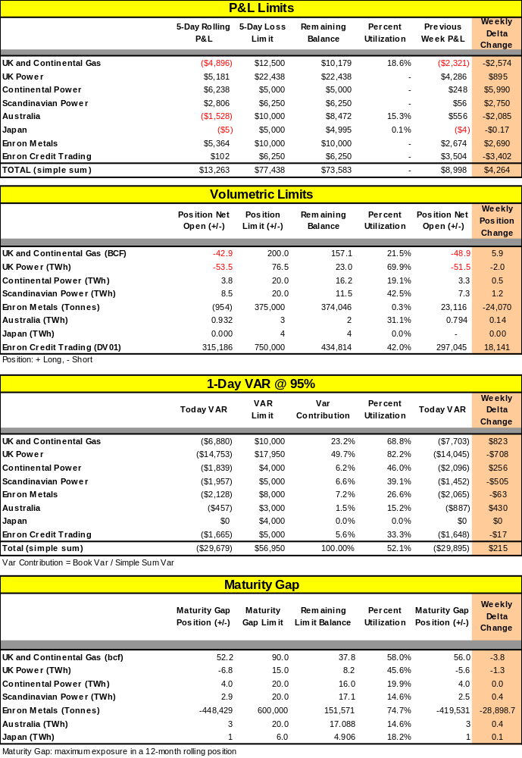

Curves and Positions

UK Power: Price Curves and Curve Shift (TBA)

UK Power: Discounted volumes and changes in volumes

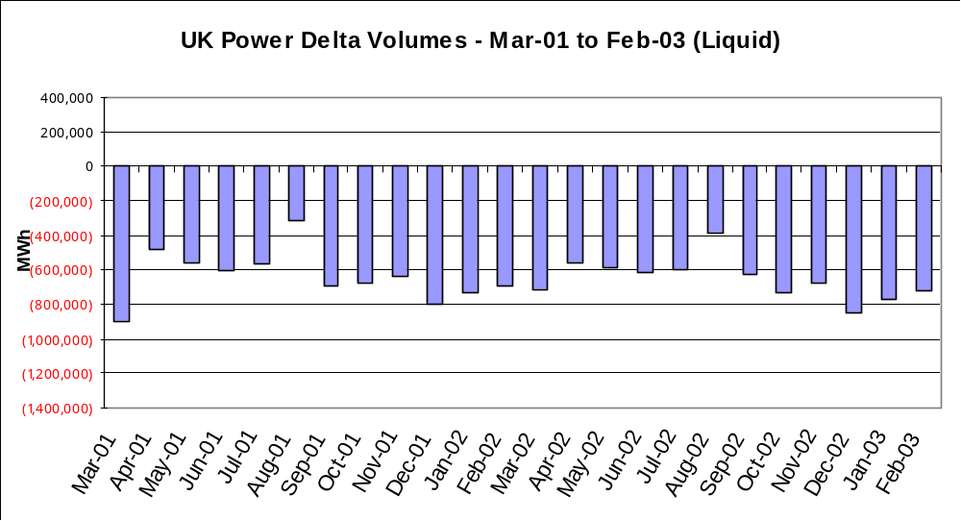

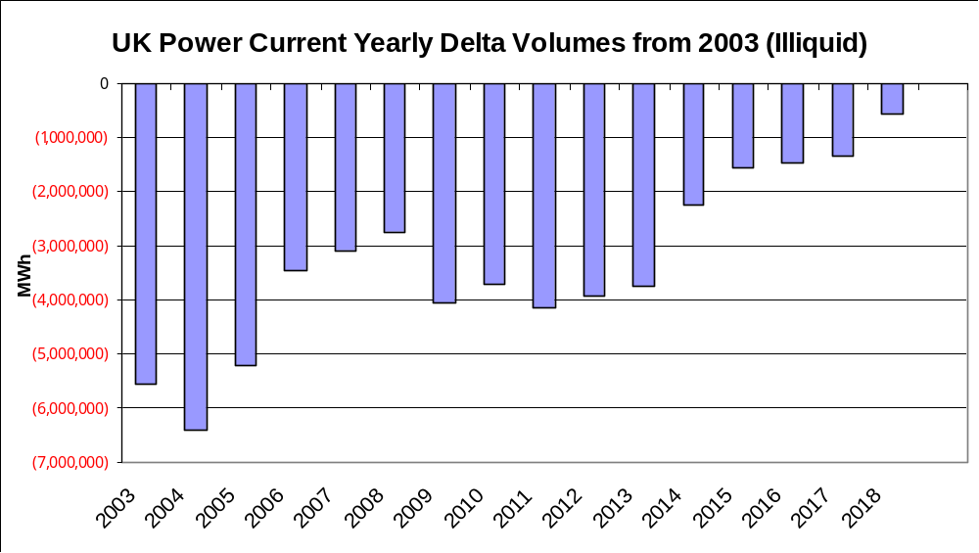

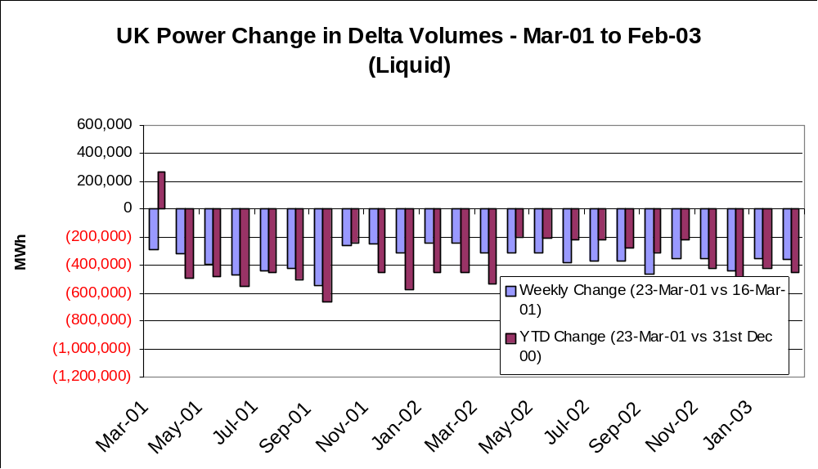

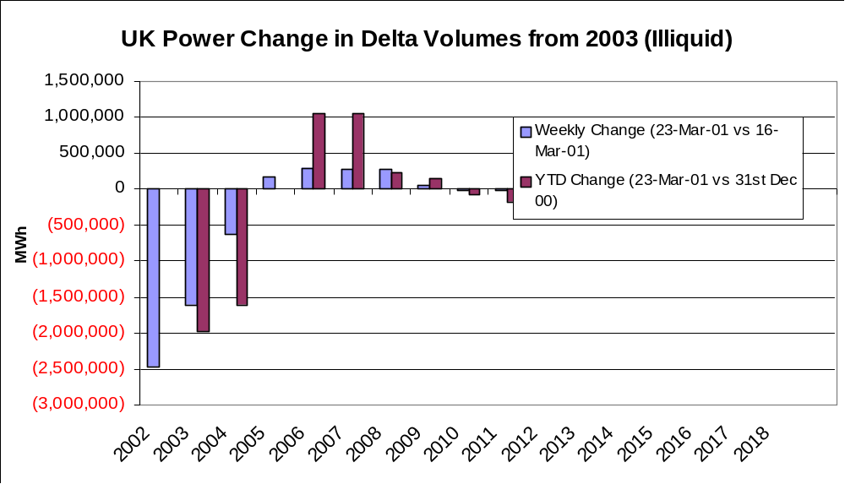

Continental Power: Price Curves and Curve Shift

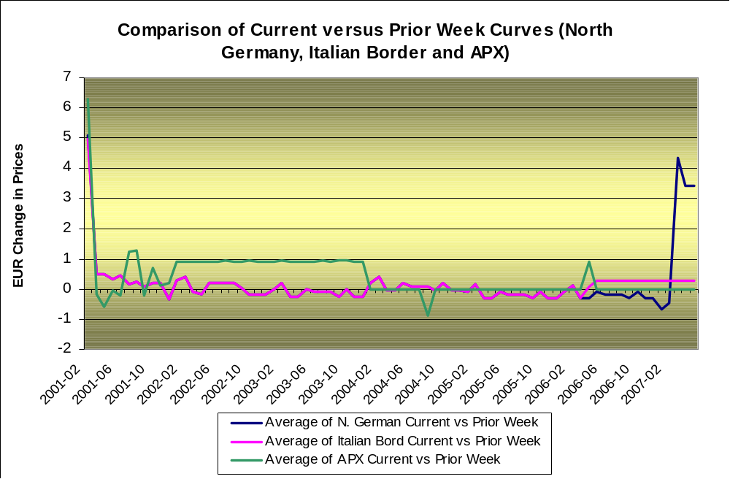

Continental Power: Bilateral discounted volumes and changes in volumes

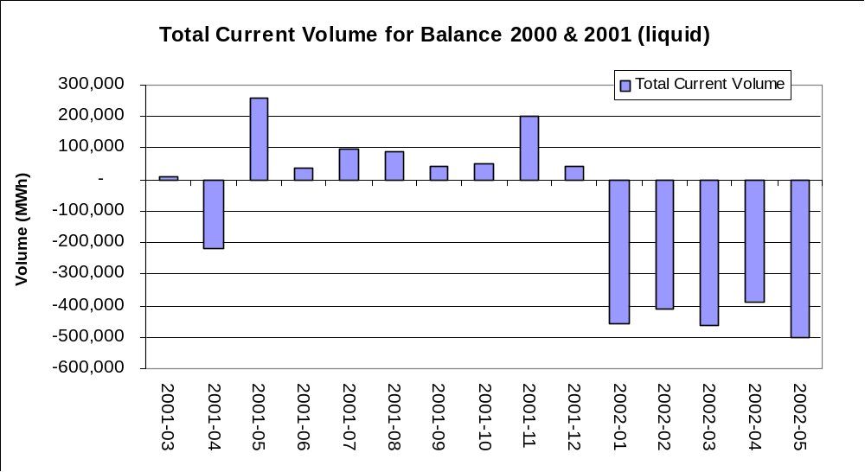

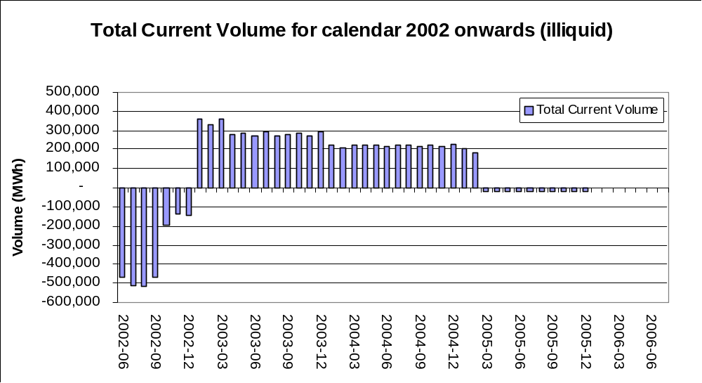

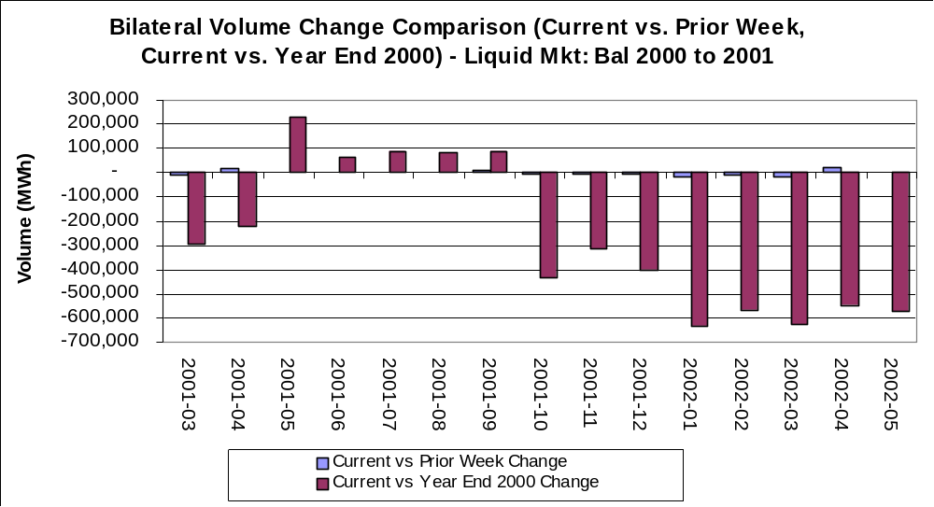

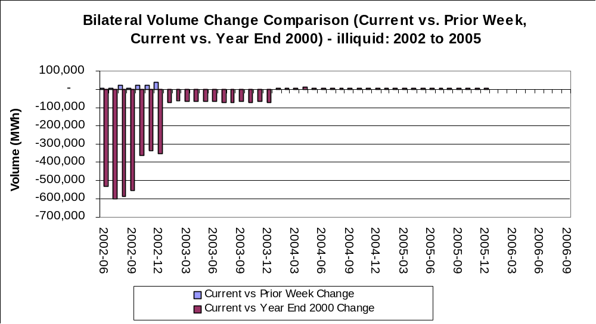

Continental Power: Pool discounted volumes and changes in volumes

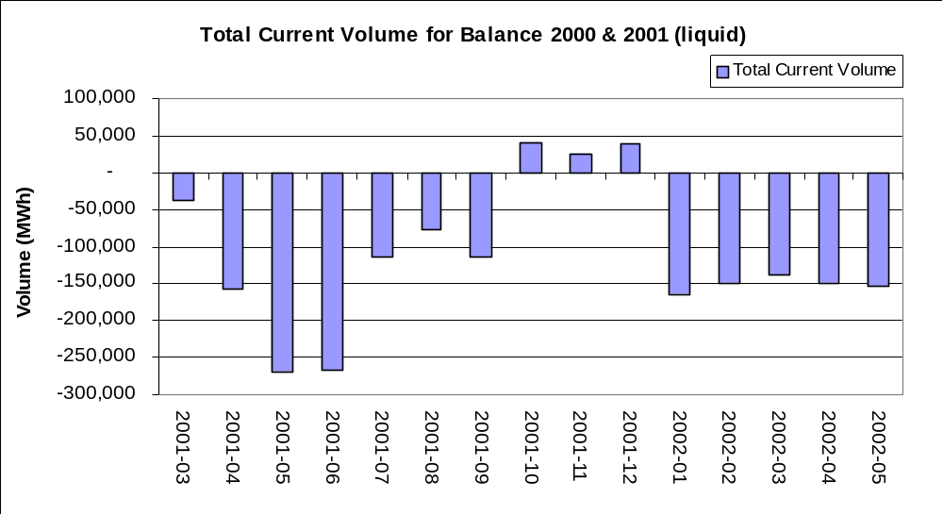

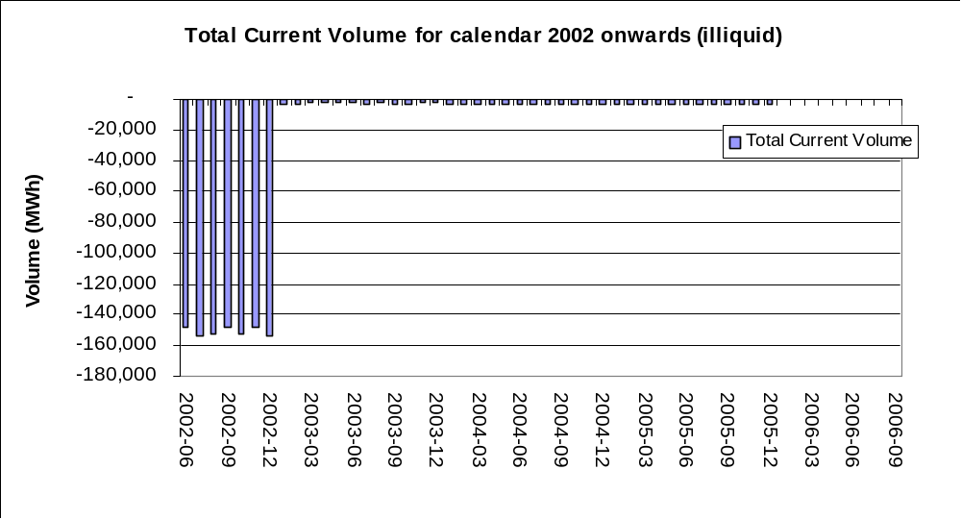

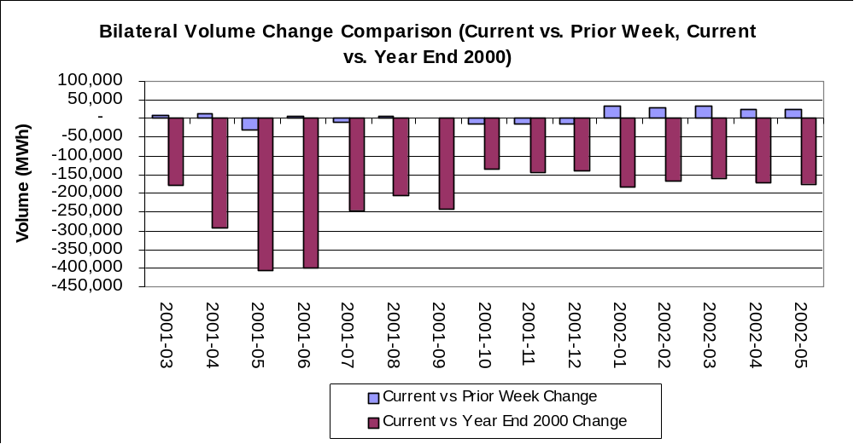

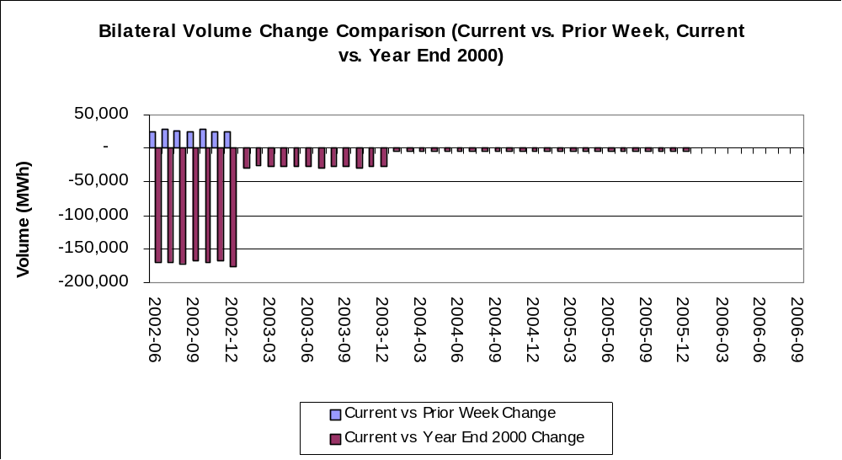

Nordic Power: Price Curves and Curve Shift

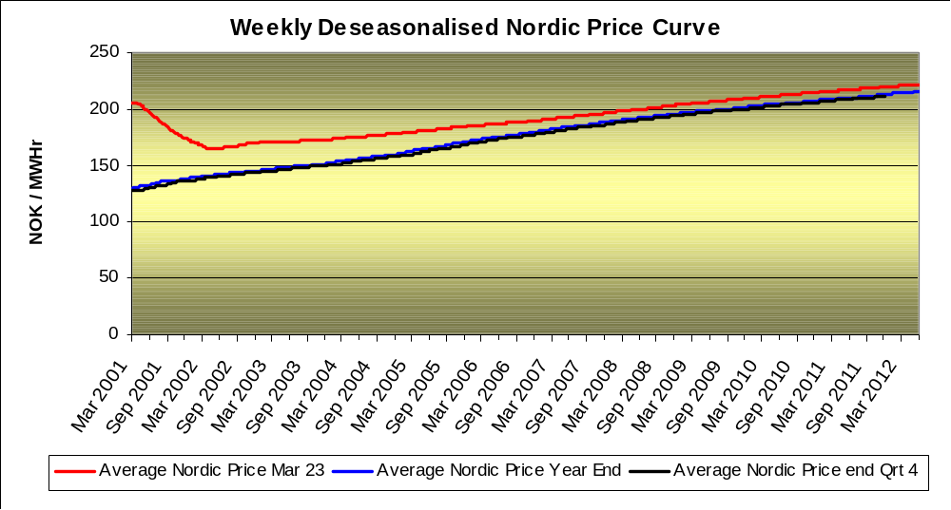

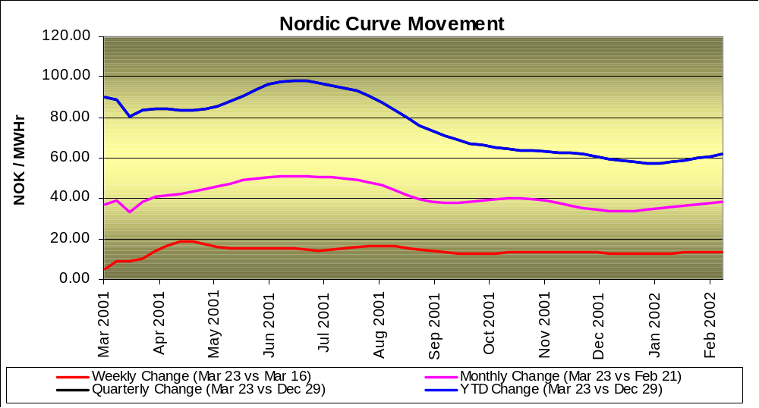

Nordic Power: Discounted volumes and changes in volumes

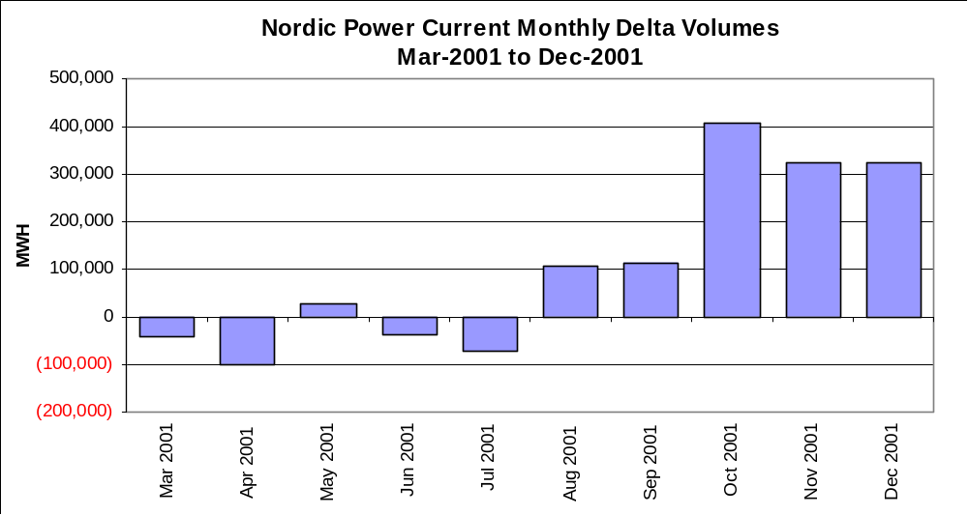

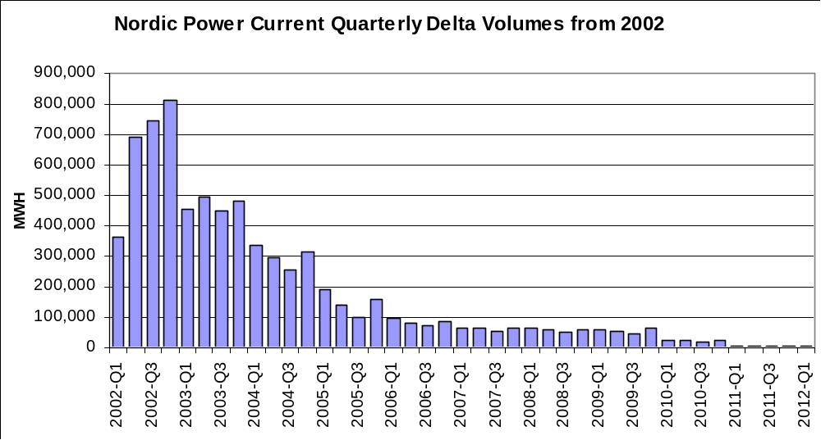

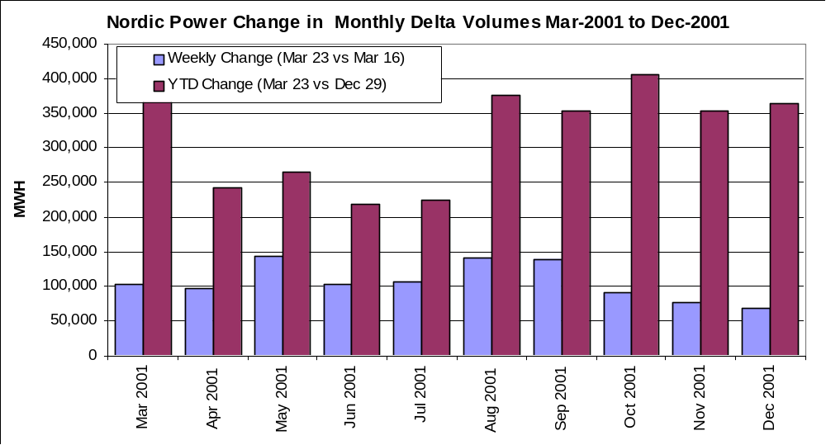

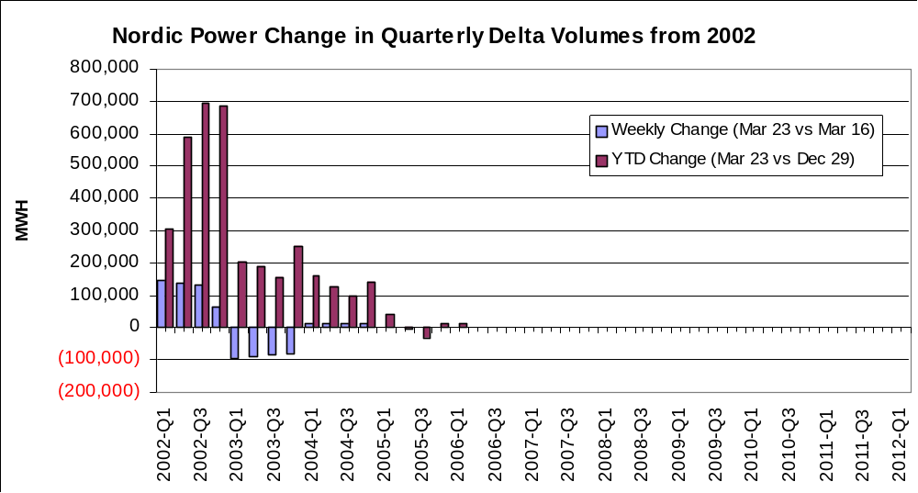

UK Gas: Price Curves and Curve Shift

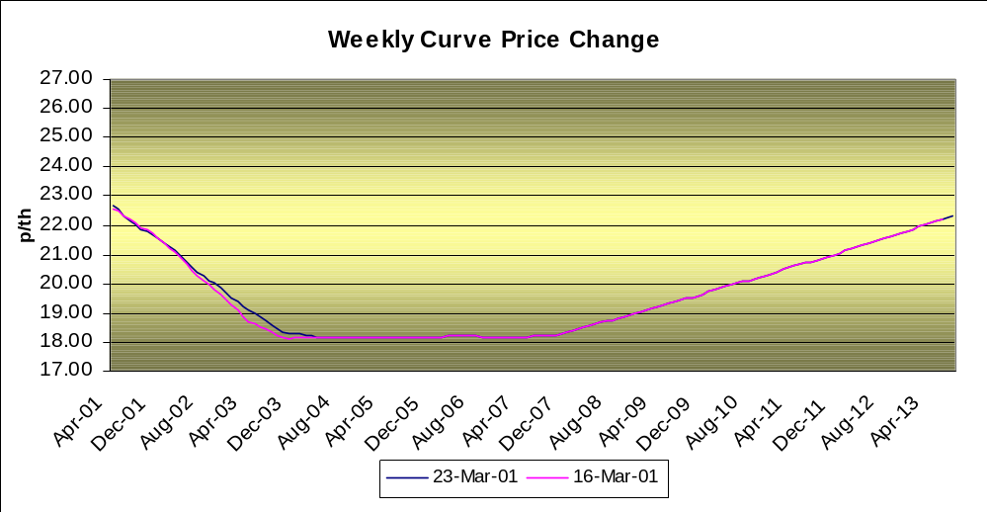

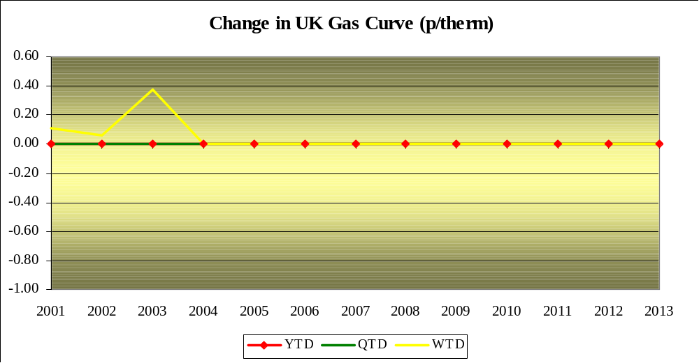

UK Gas: Discounted volumes and changes in volumes

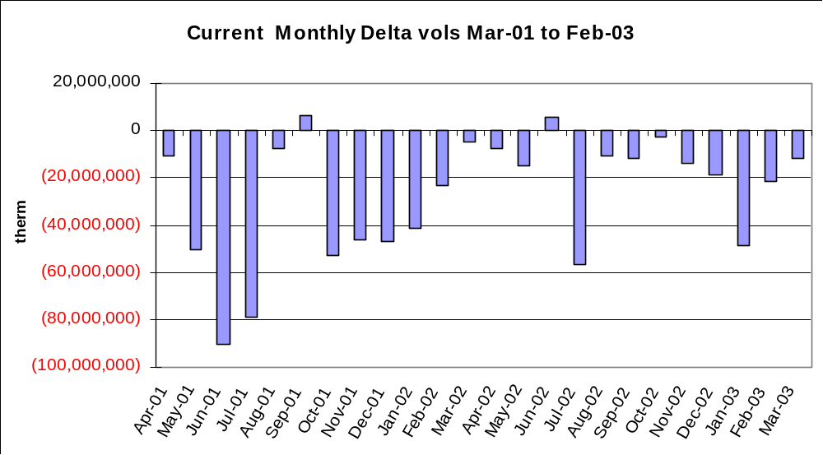

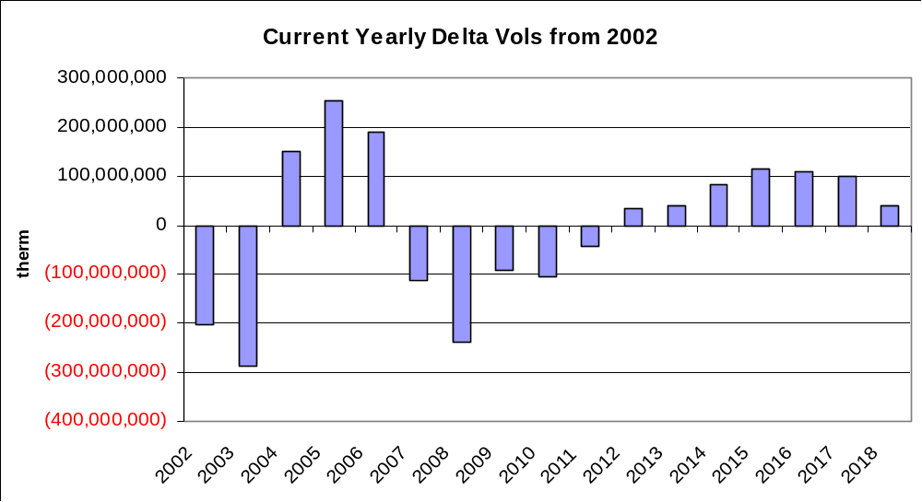

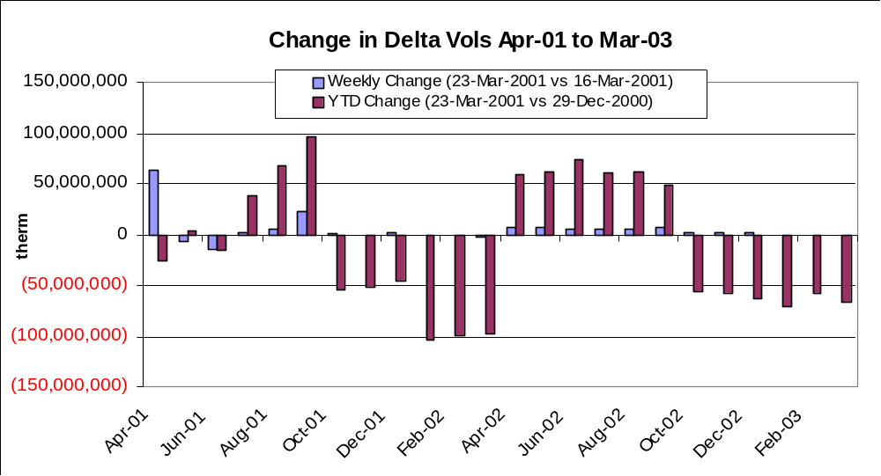

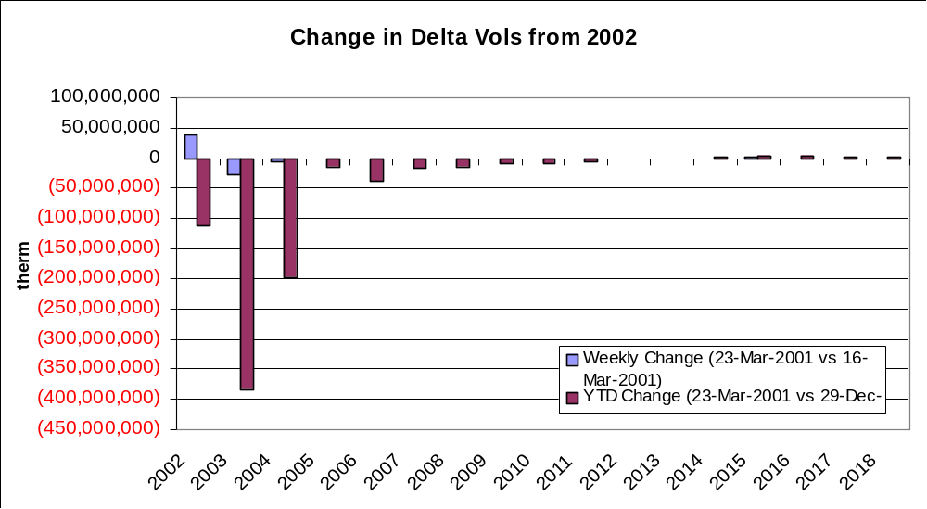

Continental Gas: Price Curves and Curve Shift

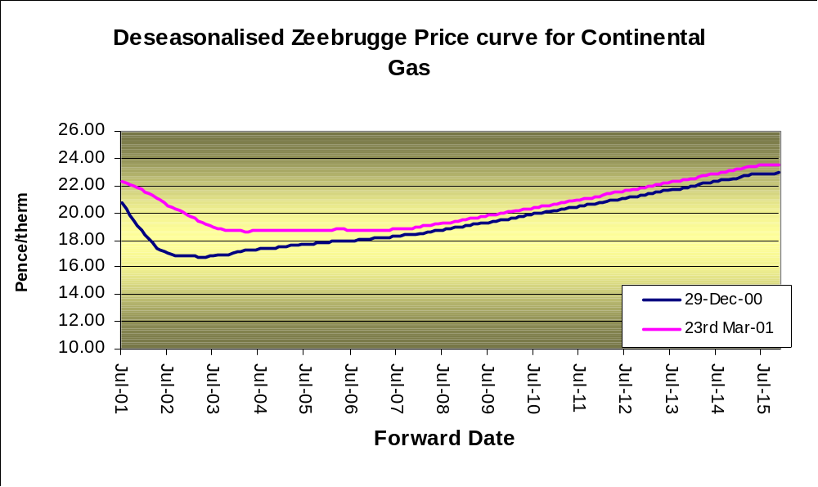

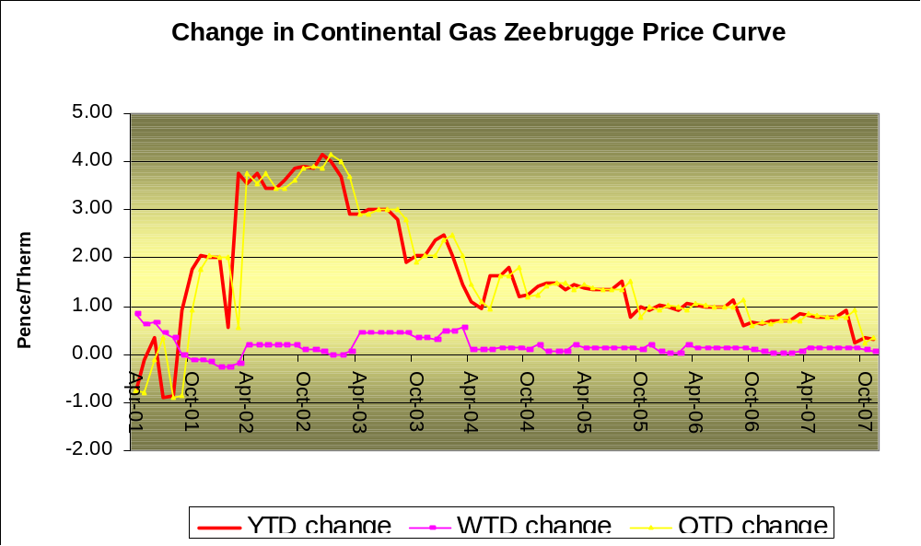

Continental Gas: Discounted volumes and changes in volumes

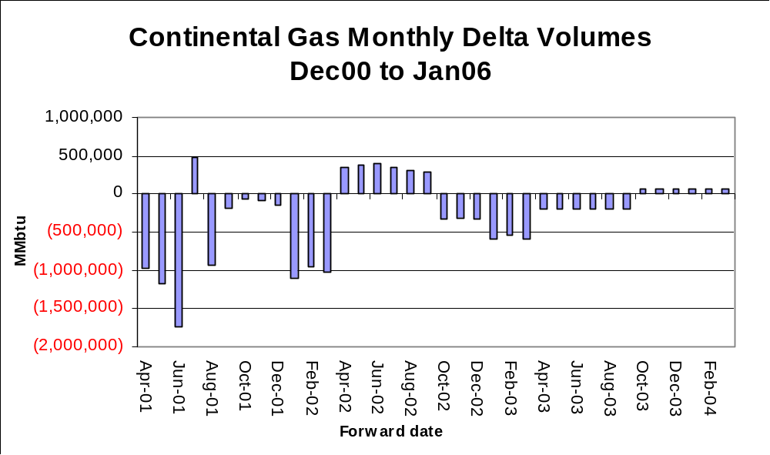

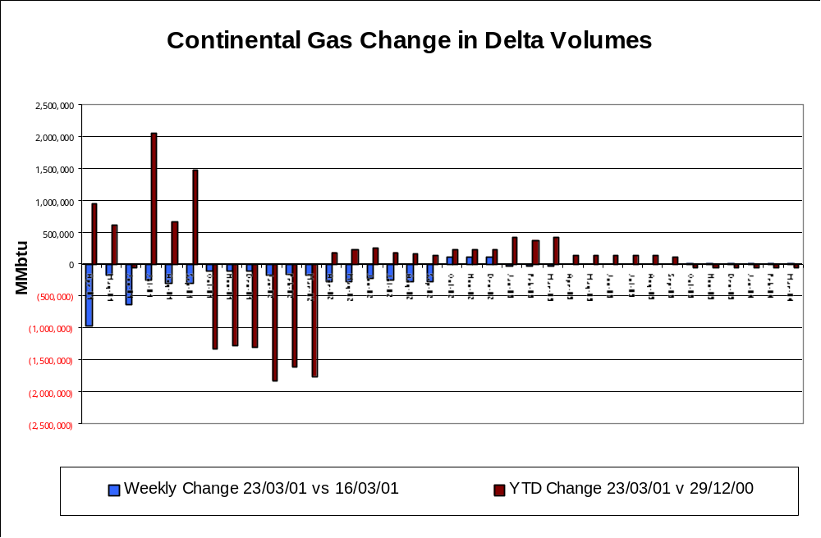

Eastern: Positions

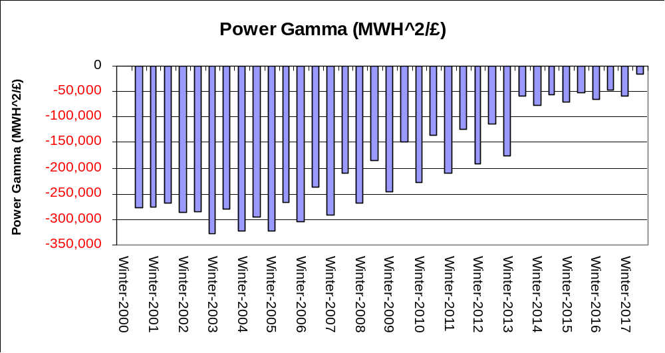

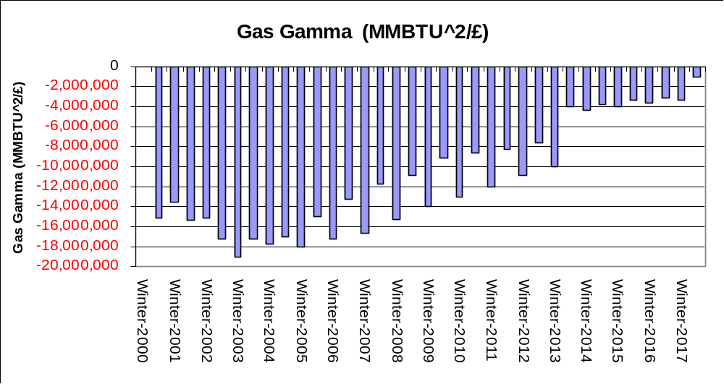

Eastern: Vega Positions

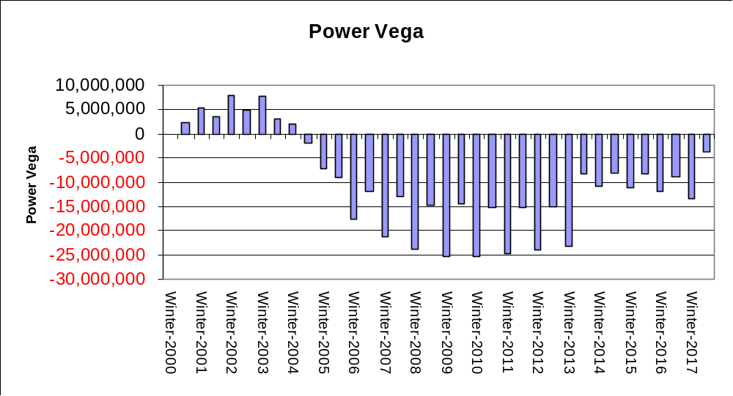

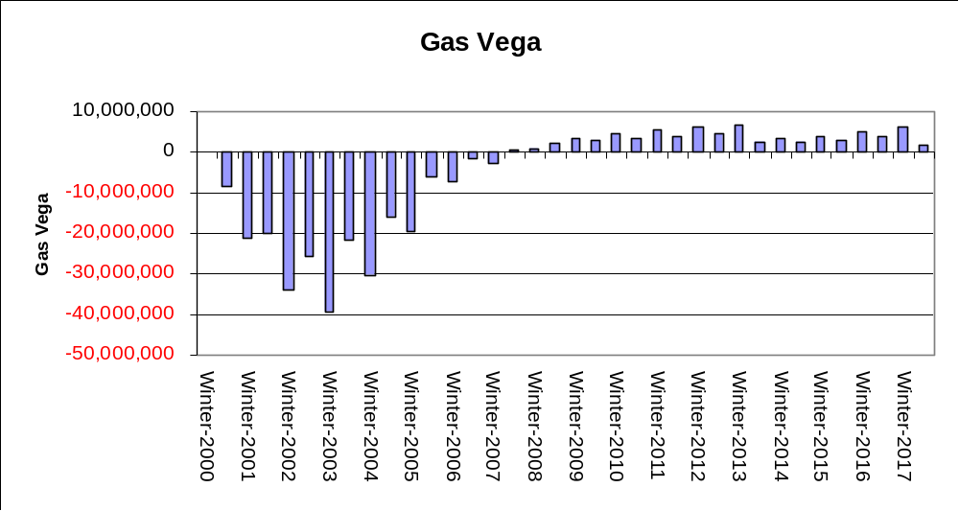

Metals: Price Curves and Curve shift

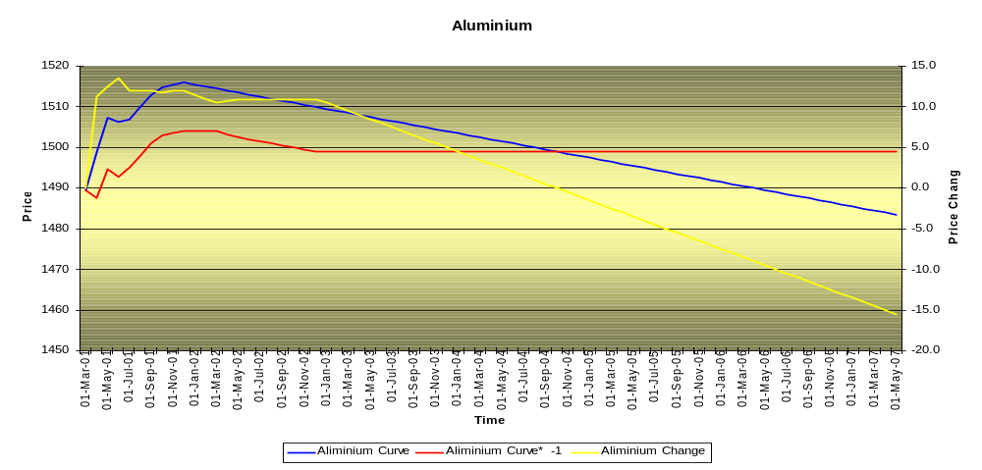

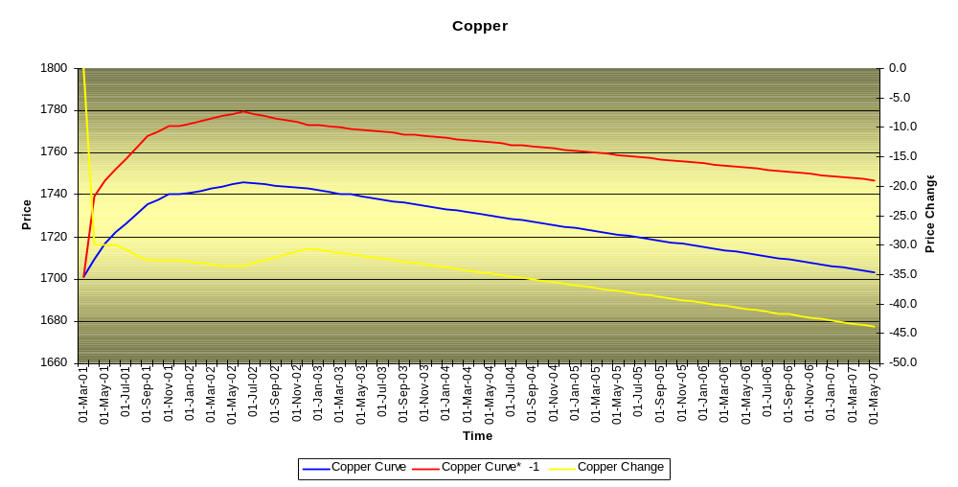

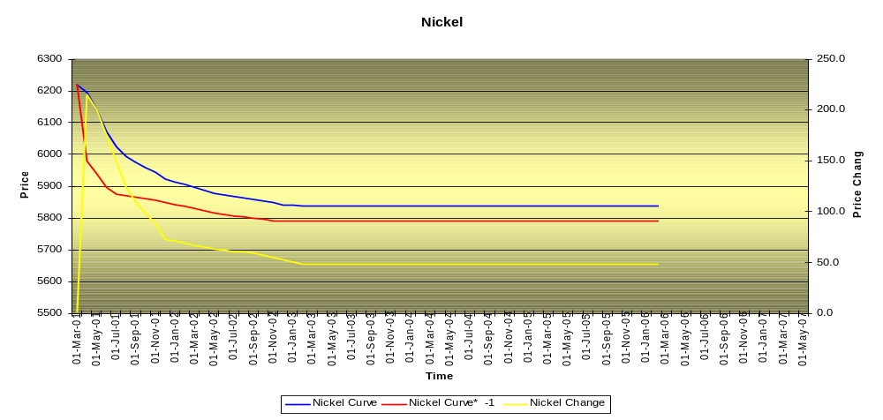

Metals: Discounted volumes and changes in volumes

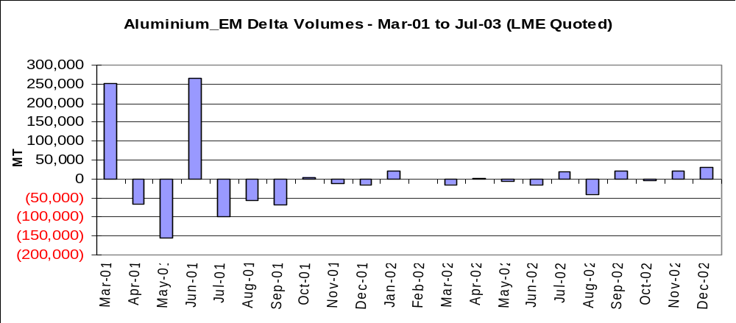

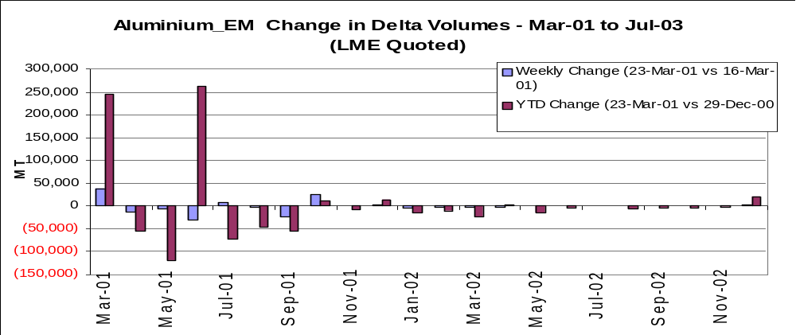

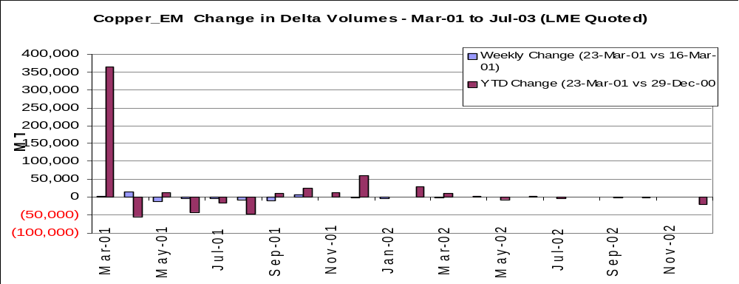

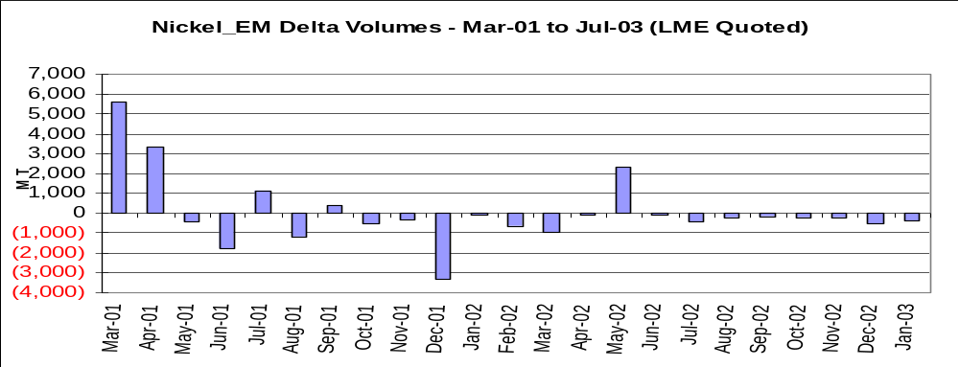

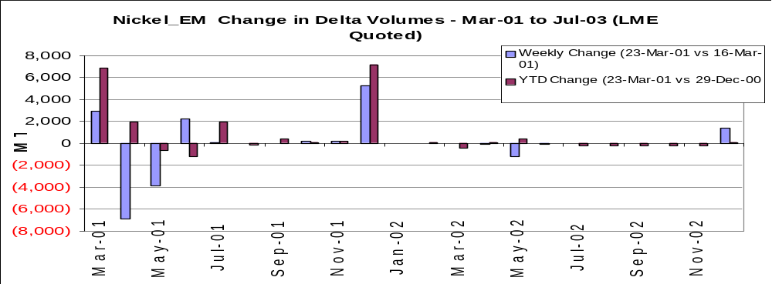

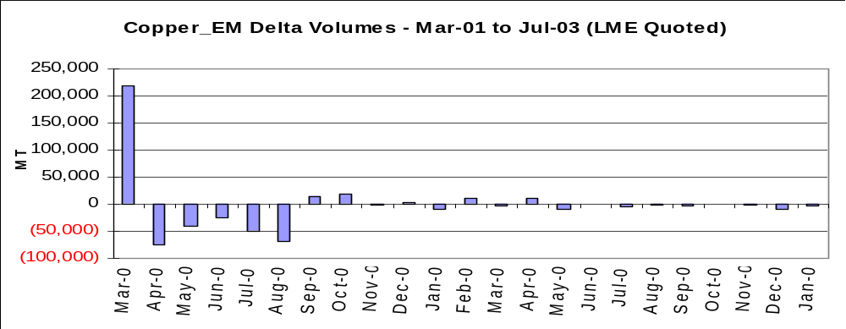

Australian Power: Price Curves and Curve Shift

Changes in Forward Prices : Four Regions – Weekly Changes
(A$ per MWh)

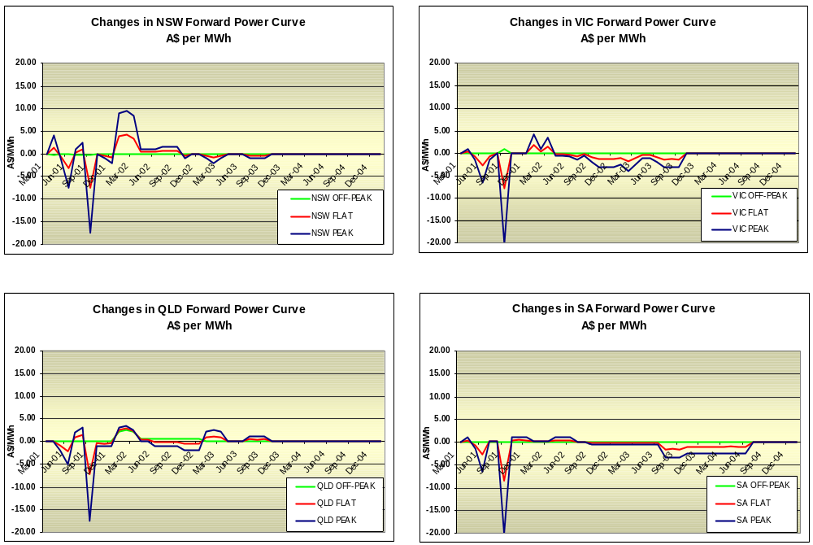

Australian Power: Discounted volumes and changes in volumes

Net Open Position : Total Power Exposure – Monthly (MWh)

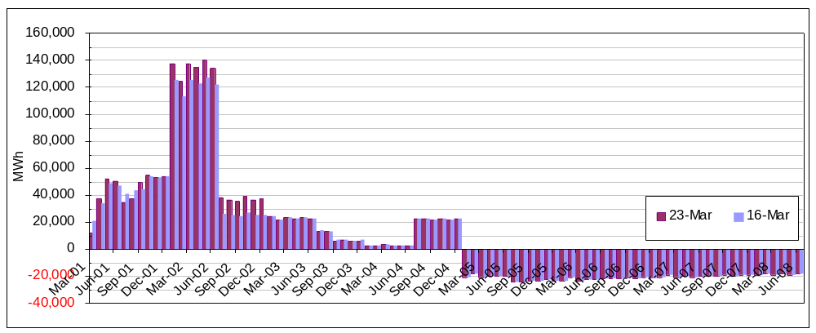

Net Open Positions : Regional Power Exposures – Monthly (MWh)

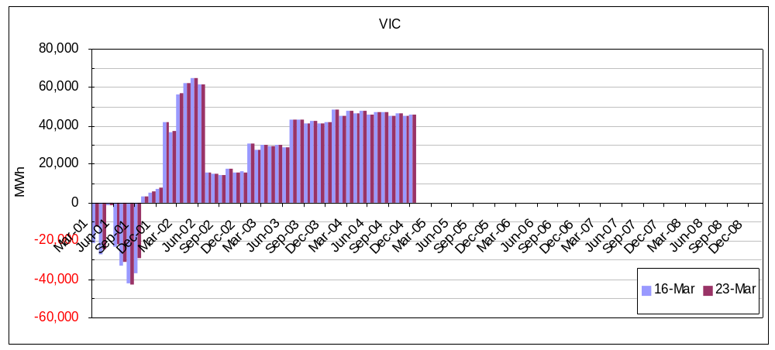

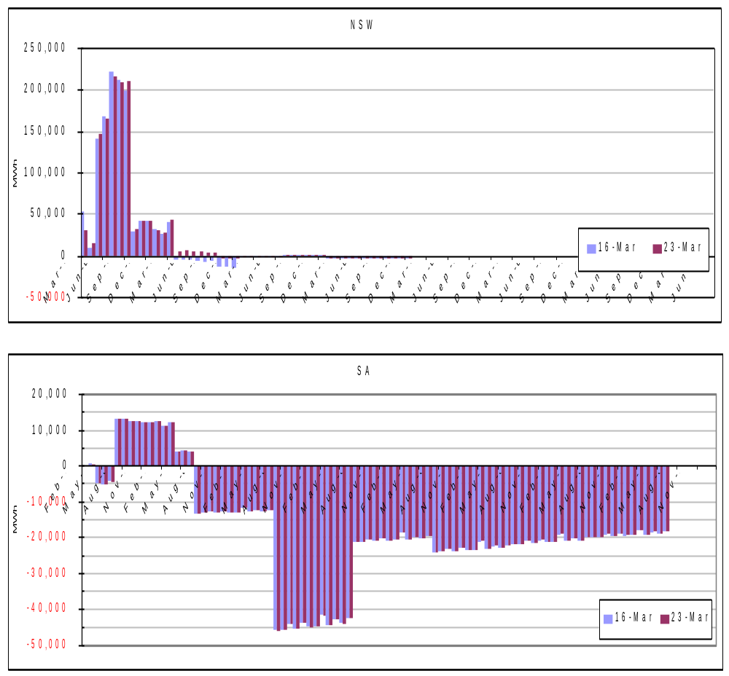

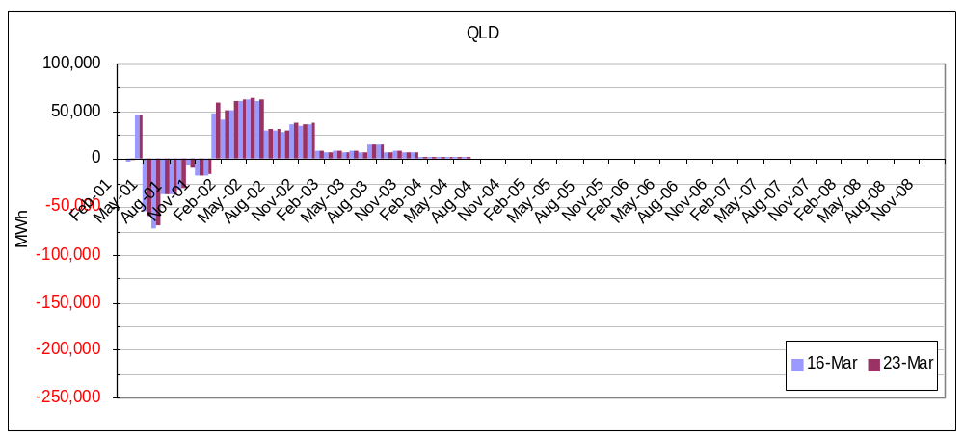

Credit Trading: Price Curves and Curves Shift

